Lab Session 6 (Open-Ended Lab 1)

Open Ended Lab
Blooms Taxonomy | GAs
C3 A2 | GA-2 GA-6

Title: SmartTelAI: Telecom Customer Churn Analytics and Customer Retention Prediction System

Motivation:
Telecommunication companies lose a significant amount of revenue every year due to customer churn. Understanding why customers discontinue services and identifying customers likely to leave are critical business problems. Data Warehousing and Machine Learning techniques can help organizations analyze customer behavior and design customer retention strategies..
Concept:

This OEL covers:

- Star, Snowflake and Galaxy Schema
- 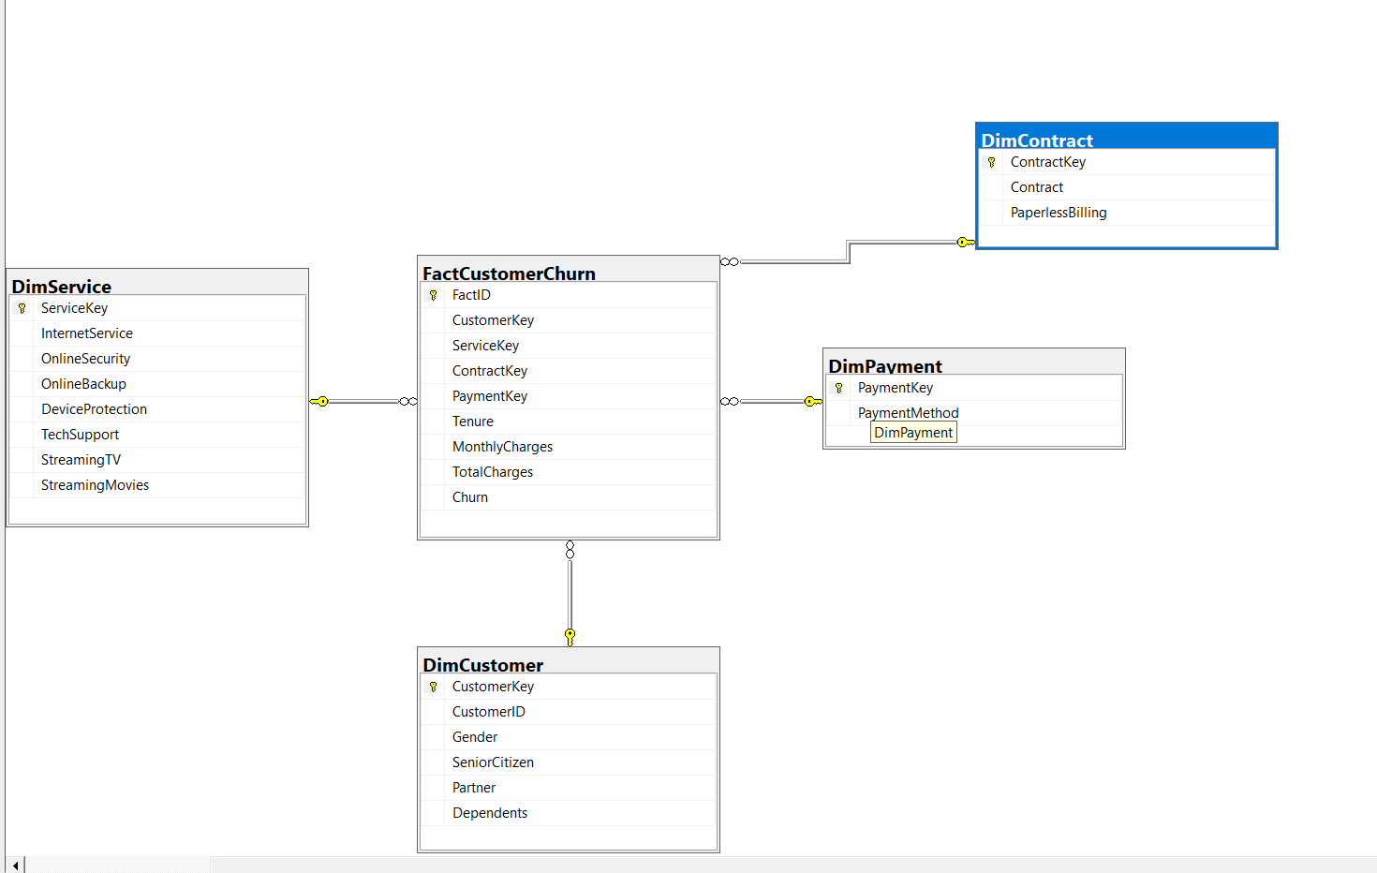
2. ETL Pipeline using SSIS

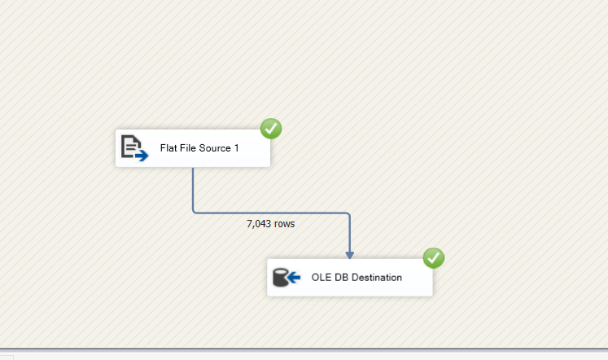
3. OLAP Operations
ROLLUP
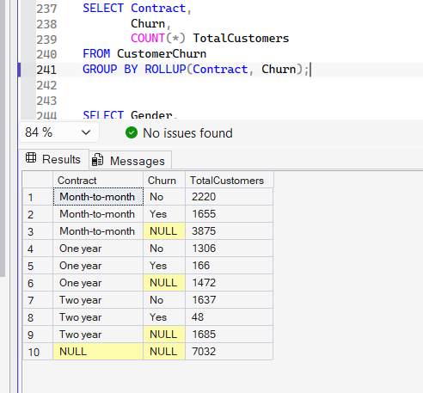
CUBE

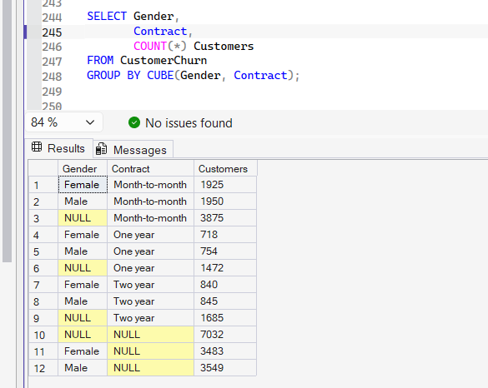
GROUPING SETS
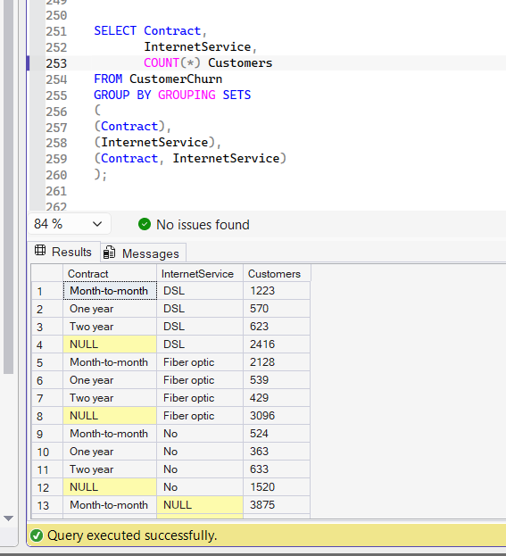
4. SQL Window Functions
ROW_NUMBER()
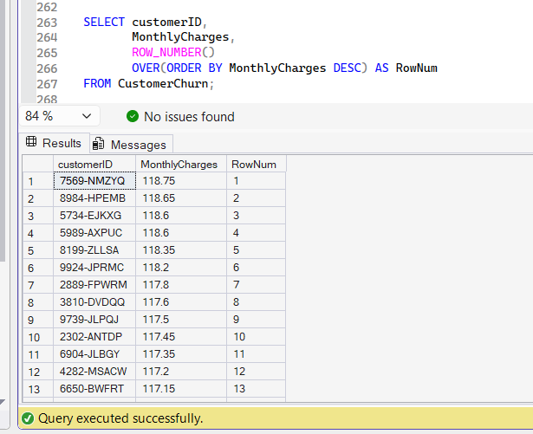

RANK()
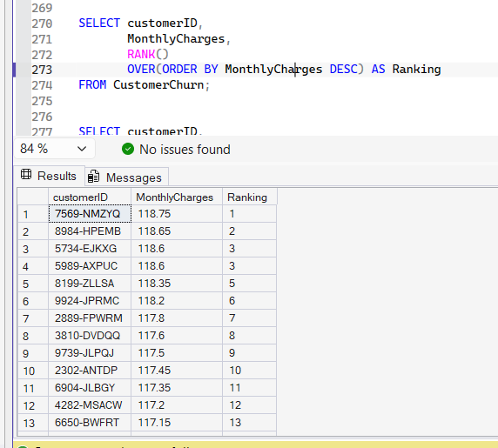
NTILE()
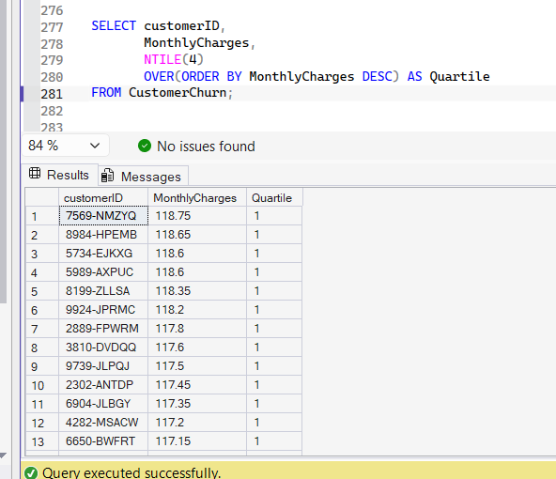
LEAD()

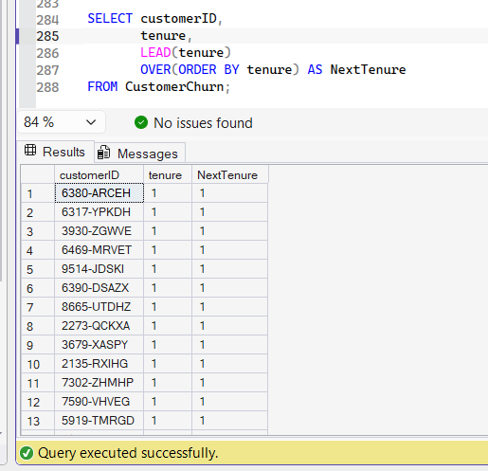
5. Machine Learning
Decision Tree
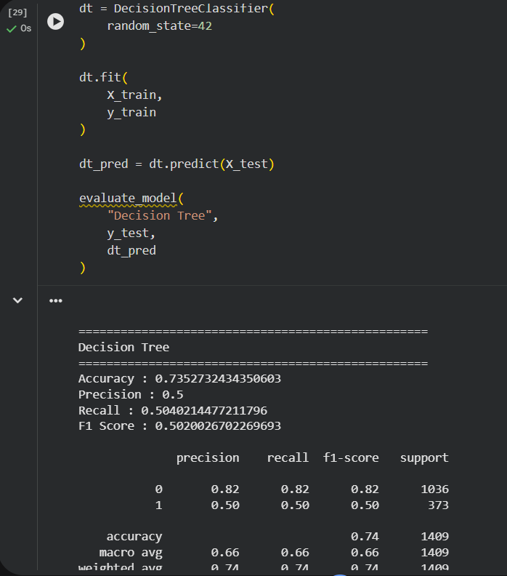

Random Forest
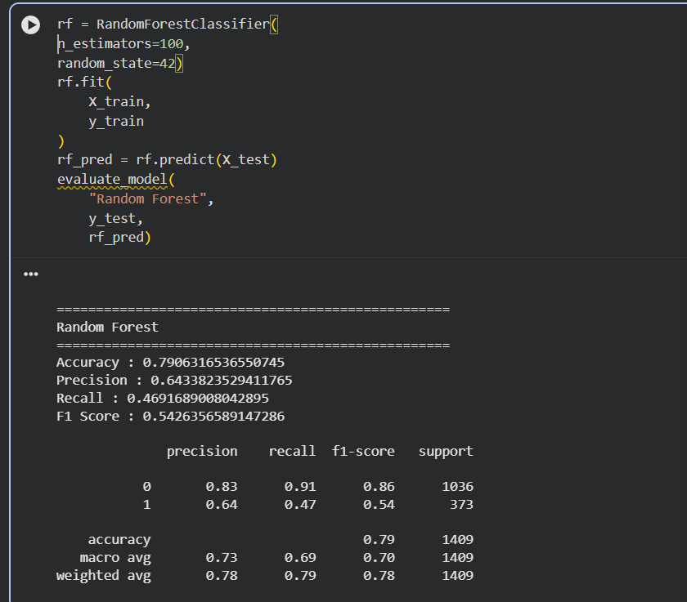
Logistic Regression

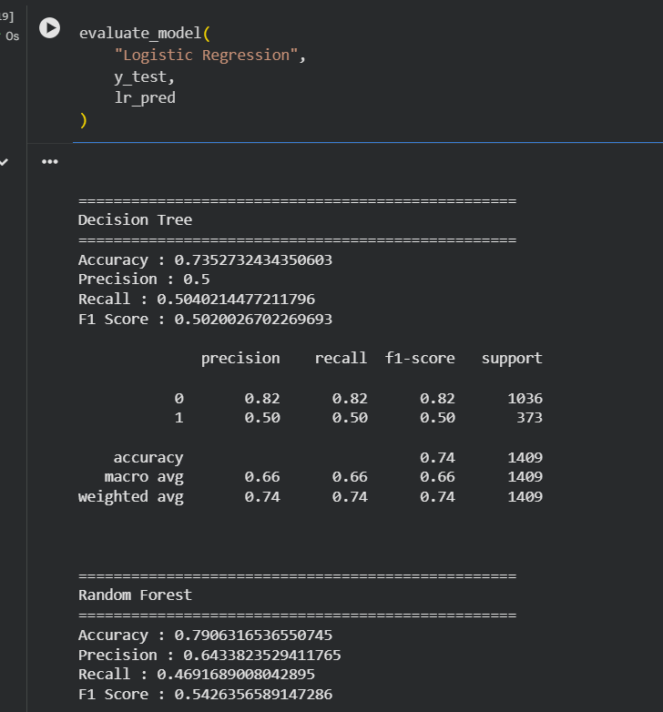
6. Feature Engineering
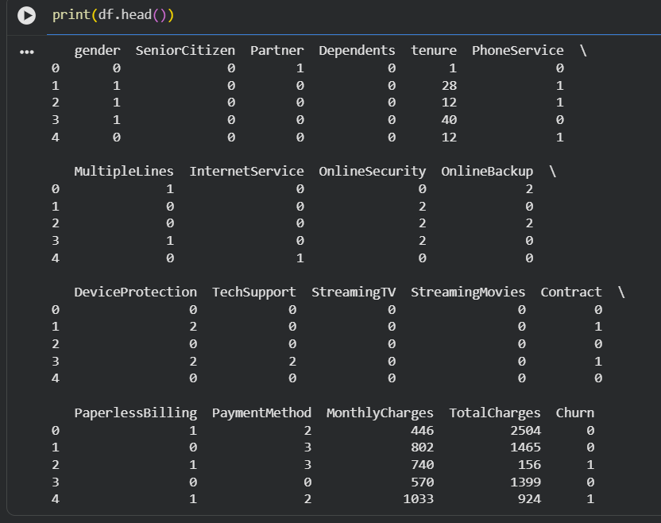
7. Model Evaluation

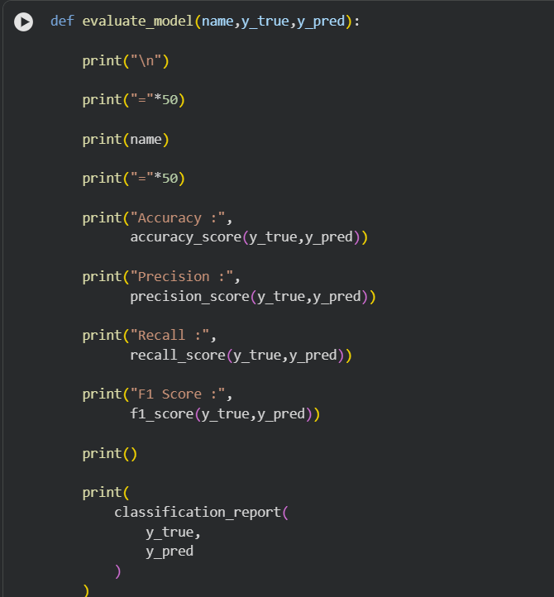
8. Business Intelligence and Customer Analytics

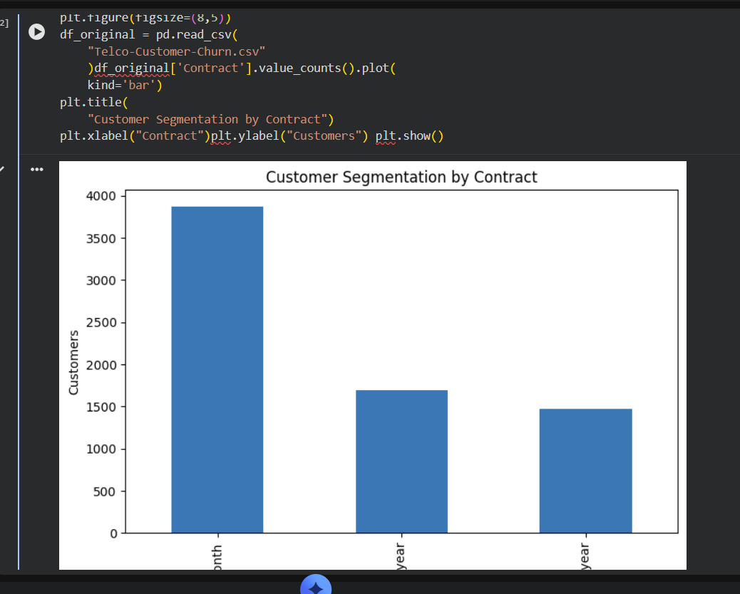

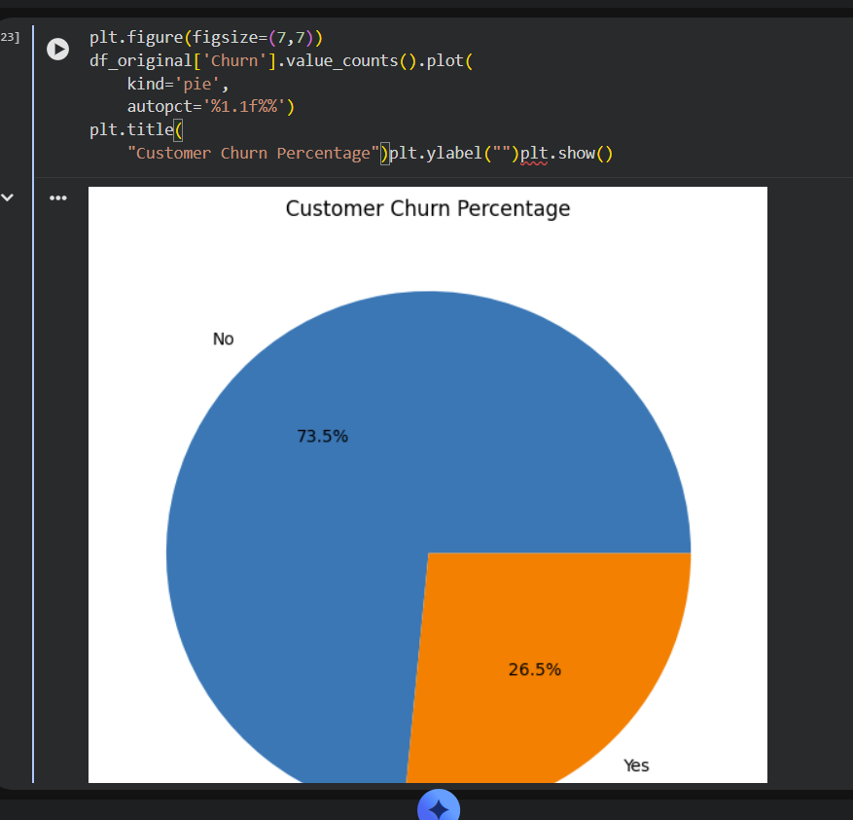

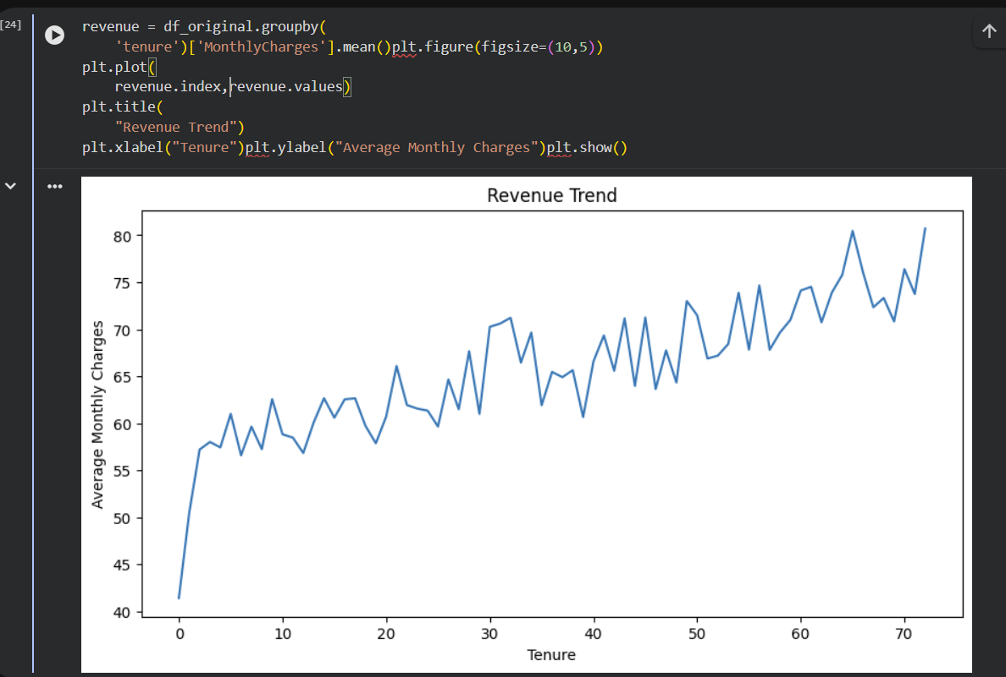

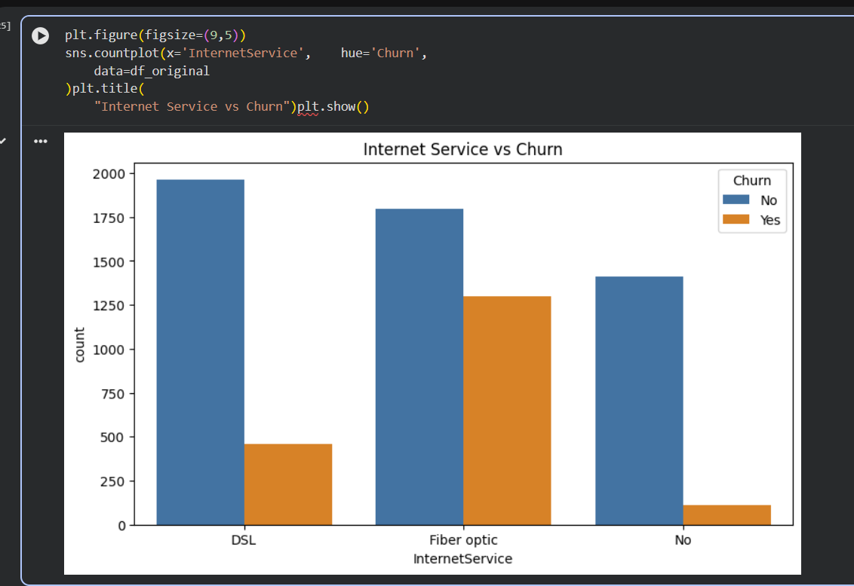
Problem Statement:
SMARTTELAI – CUSTOMER CHURN ANALYTICS DATA WAREHOUSE

A telecom company operating across Pakistan wants to investigate:

- Which customers are most likely to leave?
- Which service plans contribute to customer churn?
- Which cities generate maximum revenue?
- What factors influence customer loyalty?

The company requires:

- Design a Snowflake/Galaxy Schema.
- Import customer records using SSIS.
- Perform data cleaning and transformation.
- Generate multidimensional reports.
- Build machine learning models for churn prediction.
- Compare model performance.
- Recommend customer retention strategies.

Dataset Provided:

Telco Customer Churn Dataset
Example Attributes:
- Gender
- SeniorCitizen
- Partner
- InternetService
- Contract
- Tenure
- MonthlyCharges
- TotalCharges
- Churn
Design / Ways & Means:

Students may use the following design choices:

- Choose Star, Snowflake or Galaxy Schema.
- Select suitable dimensions and fact tables.
- Apply SQL Window Functions taught in lab.
- Use any classification algorithm covered in the course.
- Compare multiple models
No additional algorithms, functions, or libraries are allowed..

Analysis & Reporting /Answer:
Lab Activity:
1. Background / Theory
Customer churn analytics identifies customers likely to leave a telecom service. It helps companies improve retention and revenue. A Star Schema connects dimensions directly to a fact table, while a Snowflake Schema further normalizes dimensions into related tables. A Galaxy Schema contains multiple fact tables. ETL is important because it extracts, transforms, and loads data into a warehouse for analysis. Window functions help rank, group, and compare customer records. Decision Tree uses rule-based splits, Naive Bayes uses probability, Random Forest combines multiple trees, and Logistic Regression predicts churn probability. Accuracy, Precision, Recall, F1-Score, and Confusion Matrix evaluate model performance.
2. Procedure / Methodology
The project used a Snowflake Schema with dimension and fact tables. Customer data was imported through SSIS into SQL Server. Data cleaning removed duplicates and handled missing values. Feature engineering encoded categorical attributes for machine learning. The dataset was divided into training and testing sets. Decision Tree, Naive Bayes, Random Forest, and Logistic Regression models were trained and compared using evaluation metrics.
3. Data Collection
Dataset Source: Telco Customer Churn Dataset. Number of records: 7043. Features include Gender, SeniorCitizen, Partner, InternetService, Contract, Tenure, MonthlyCharges, TotalCharges, and Churn. Target Variable: Churn. The dataset is useful for analyzing customer behavior and predicting churn.
4. Flowchart / Block Diagram

SSIS ETL

Snowflake Schema

Data Missing Values Duplicate Removal Outlier Handling

Machine Learning Decision Tree
Random Forest
Logistic Regression
Cleaning

Customer Analytics Dashboard Churn Percentage Revenue Trends Prediction Outcomes

5. Results & Comparison
Snowflake Schema was created successfully. SSIS ETL loaded the dataset correctly. Missing and duplicate values were handled. SQL analytics and machine learning models generated useful insights. Random Forest generally produced the best prediction accuracy.
6. Discussion on Results
SSIS successfully loaded all records without major mapping issues. Handling missing TotalCharges values was the most important cleaning step because incomplete data affects prediction quality. A challenge was encoding categorical attributes for machine learning.
7. Concluding Remarks
The project successfully implemented customer churn analytics using SQL Server, SSIS, and machine learning. The warehouse supported reporting and predictive analysis. Random Forest achieved strong results. Future work can include clustering and explainable AI techniques.
8. References (IEEE Style)
[1] I. H. Witten, E. Frank, and M. A. Hall, Data Mining: Practical Machine Learning Tools and Techniques, 3rd ed., 2011.
[2] J. Han, M. Kamber, and J. Pei, Data Mining: Concepts and Techniques, 3rd ed., 2012.
[3] T. Hastie, R. Tibshirani, and J. Friedman, The Elements of Statistical Learning, 2009.
[4] L. Breiman, "Random Forests," Machine Learning, vol. 45, no. 1, 2001.
[5] C. M. Bishop, Pattern Recognition and Machine Learning, 2006.

CLO Category | CLO domain | Marks | Obtained marks
CLO 1(15marks) | Apply DWDM  Concepts. | 15
CLO 2(15marks) | Participate in implementing  advanced DWDM tasks. | 15
Total |  | 30

